

**“AZƏRBAYCAN HAVA YOLLARI” CJSC**

**NATIONAL AVIATION ACADEMY**

**Topic**: What is VPN

**Subject**: Operating Systems

**Teacher**: Mammad Sahmaliyev

**Group**: 2450i

**Student**: Alakbarova Rahimakhanim

**Date**: 21.11.22

**Signature**: Alakbarova Rahimakhanim

**Baku 2022**

A VPN (virtual private network) is the easiest and most effective way for people to protect their internet traffic and keep their identities private online. As you connect to a secure VPN server, your internet traffic goes through an **encrypted tunnel that nobody can see into**, including hackers, governments, and your internet service provider.

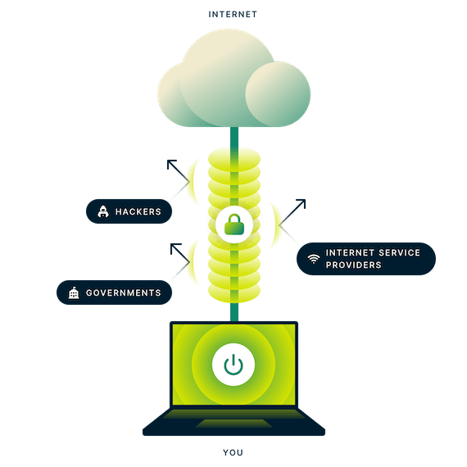

A VPN, or Virtual Private Network, allows you to create a secure connection to another network over the Internet. VPNs can be used to access region-restricted websites, shield your browsing activity from prying eyes on public Wi-Fi, and more.In very simple terms, a VPN connects your PC, smartphone, or tablet to another computer (called a server) somewhere on the internet, and allows you to browse the internet using that computer’s internet connection. So if that server is in a different country, it will appear as if you are coming from that country, and you can potentially access things that you couldn’t normally.

**How Does a VPN Work?**

When you connect your computer (or another device, such as a smartphone or tablet) to a VPN, the computer acts as if it’s on the same local network as the VPN. All your network traffic is sent over a secure connection to the VPN. Because your computer behaves as if it’s on the network, this allows you to securely access local network resources even when you’re on the other side of the world. You’ll also be able to use the Internet as if you were present at the VPN’s location, which has some benefits if you’re using public Wi-Fi or want to access geo-blocked websites.

When you browse the web while connected to a VPN, your computer contacts the website through the encrypted VPN connection. The VPN forwards the request for you and forwards the response from the website back through the secure connection. If you’re using a USA-based VPN to access Netflix, Netflix will see your connection as coming from within the USA.

**Other Example Uses for VPNs**

VPNs are a fairly simple tool, but they can be used to do a wide variety of things:

* **Access a Business Network While Traveling**: VPNs are frequently used by business travelers to access their business’ network, including all its local network resources, while on the road. The local resources don’t have to be exposed directly to the Internet, which increases security.
* **Access Your Home Network While Traveling**: You can also set up your own VPN to access your own network while traveling. This will allow you to access a Windows Remote Desktop over the Internet, use local file shares, and play games over the Internet as if you were on the same LAN (local area network).
* **Hide Your Browsing Activity From Your Local Network and ISP**: If you’re using a public Wi-Fi connection, your browsing activity on non-HTTPS websites is visible to everyone nearby, if they know how to look. If you want to hide your browsing activity for a bit more privacy, you can connect to a VPN. The local network will only see a single, secure VPN connection. All the other traffic will travel over the VPN connection. While this can be used to bypass connection-monitoring by your Internet service provider, bear in mind that VPN providers may opt to log the traffic on their ends.
* **Access Geo-Blocked Websites**: Whether you’re an American trying to access your Netflix account while traveling out of the country or you wish you could use American media sites like Netflix, Pandora, and Hulu, you’ll be able to access these region-restricted services if you connect to a VPN located in the USA.
* **Bypass Internet Censorship**: Many Chinese people use VPNs to get around the Great Firewall of China and gain access to the entire Internet. (However, the Great Firewall has apparently started interfering with VPNs recently.)
* **Downloading Files**: Yes, let’s be honest — many people use VPN connections to download files via BitTorrent. This can actually be useful even if you’re downloading completely legal torrents — if your ISP is throttling BitTorrent and making it extremely slow, you can use BitTorrent on a VPN to get faster speeds. The same is true for other types of traffic your ISP might interfere with (unless they interfere with VPN traffic itself.)